|  |  |  |  |
| --- | --- | --- | --- |
|  |  | |  | | --- | | TRINITY TODAY NEWSLETTER |  * August ………....132 Meals Served * September……..144 Meals Served * October………...120 Meals Served * November…….. 108 Meals Served * December……… 76 Meals Served * January………….76 Meals Served |
|  |  |  |



We continue our mission of serving monthly Community Social Lunches. This is made possible by the generous endowment from the Drum Family which was earmarked specifically for outreach in the Carbondale community. We discovered that these meals actually cost nothing but our time and talent as the Account earns enough interest to cover expenses. We serve an average of 90 meals each month. All are welcome to come and help prepare, serve, greet or eat with us. We try to schedule lunches on the third Saturday of the month from 12 PM – 1 PM. Christ Church in Forest City has their Community Lunch on the fourth Saturday.



Monday -Friday

8:30 am - 12:30 pm

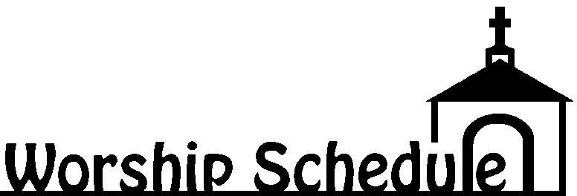

***Holy Eucharist Sunday @ 11:00 am***

***Reverend Bill McGinty***

* Chicken & Biscuits Dinner – May 18th
* Lynette’s Twirlerettes practice in large hall on Wednesdays
* Monthly Free Community Social Lunches
* Weekly Knitting/Craft Group- Friday afternoons 3:00pm–4:00pm
* Chicken & Biscuit Dinner – September 24th
* Diocese Convention – September 29th & 30th
* Blessing of Pets – October 8th
* Designer Purse Bingo – October 14th
* Holiday Bazaar - October 28th
* Roast Beef Dinner – November 9th
* 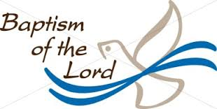Christmas Cookie Sale – December 10th & 17th
* Dicken’s Dinner – December 16th



**There were no winners on Novembers Lottery Tickets** Arianna Rae Kania September 24th, 2017

Shylar Jean Sosa September 24th, 2017

February Lottery Tickets are now on Sale for $5!

Melissa Hopkins November 12th, 2017



Sal Falsone October 11th

Cathy Sue Loyack October 18th

Jerry Minton October 21st

Elizabeth McHale October 23rd

Ray Arthur October 29th

Andrew Loyack November 3rd

Mark Petrokonis November 4th

Rodney Gravin November 6th

Glen Kapschull November 7th

Ed Bannon November 9th

Beck Murray November 19th

Ken Virbitsky November 19th

Madeline McHale November 22nd

Theresa Chubb December 2nd

Lucas Nevins December 7th

Maria Virbitsky December 19th

Randi Bannon December 20th

Ryan Bannon December 22nd

Donna Kapschull December 30th

Gary Loyack January 5th

Peter Barnes January 5th

Kathie Nevins January 14th

Zach Schaible February 17th

Gracelyn Gravine February 18th

Matthew Gillette February 23rd

Lisa Gillette February 27th

Ethyl Dougherty March 1st

Elinor Daley March 3rd

Colin Bannon March 20th

Michael Honeywell March 20th

Emelia G Robinson March 20th

Jaki Sheare March 22nd

Shelby Gebert April 17th

Aaron Loyack April 21st

Jerry & Mary Lou Williams October 18th

Dave & Peggy Mancuso October 21st

Ryan & Randi Bannon November 10th

Glen & Donna Kapschull November 14th

Gary & Cathy Sue Loyack December 3rd

Glen & Bonnie Bay January 8th



Robert & Sandra Hickey January 17th

Fr. Steve & Maureen Matelywicz January 18th

Ray & Mary Arthur February 2nd

George & Beth Chaballa February 13th

David & Mary Ann Barnes March 21st



**CHURCH SERVICE & ACTIVITY CANCELLATIONS**

We have a special telephone line to inform everyone if church service or activities will be cancelled due to bad weather or unseen circumstances. PHONE: (570) 680-1900



**Weekly Bulletin, Newsletters & Website:** Additions, corrections or changes to either of these can be made by contacting (570) 282-3620 or [trinitychurch@echoes.net](mailto:trinitychurch@echoes.net) or www.trinity episcopal.weebly.com



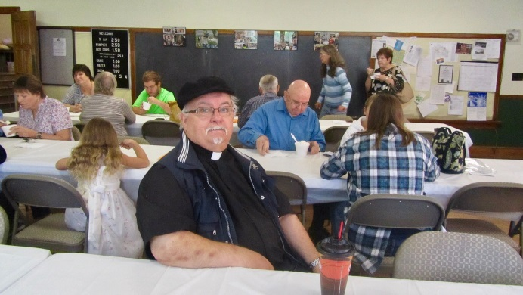This year Trinity is grateful for so many blessings, the best being Father Bill McGinty signing on to be our Pastoral Leader. We look forward to his inspirational homilies as well as his gifts of song and musical talent to collaborate with our devotional music leader, Dawn.



**God’s Blessing on *Fr. Stephen Matylewicz’***

**39 Year Anniversary of Ordination**

With prayers of gratitude for your dedicated service and for sharing so generously the gifts you have received from God.

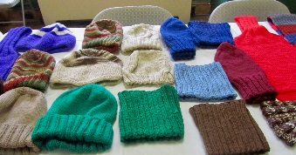**Trinity's  Knitting Group** has been very active throughout the past year.  We have prepared and mailed a box of knitted garments to the Christmas-at-Sea program, including scarves, hats, slippers and even a sweater.  The program is part of the work of the Seamen's Church Institute. Many of the gifts go to both men and women who work all year transporting goods throughout the world. Two members of our group also knit and crochet small garments for newborns, Our group meets weekly, on Friday from 3 to 4, to knit, chat and exchange patterns and ideas.  We would welcome new members, and will provide lessons as needed.

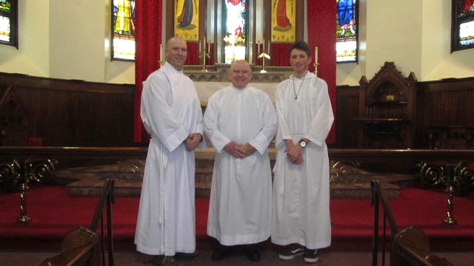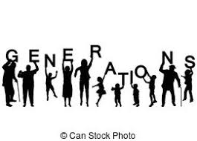

|  |  |  |
| --- | --- | --- |
| **Routine Income and Expenses 2017** | | |
| **Income** | **Expense** | **Balance** |
| $70,813.31 | $66,221.74 | $5,340.97 |
| **Capital expenses in 2017** | | |
| **Repairs** | **Cost** | **Paid by** |
| Chimney Repairs | $7,000 | Trinity |
| Church repairs furnace blow back | $156,103.23 | Church Ins. $155,133.99  Donation: $972.24 |
| Exterior repairs to church mortar | $7,800 | Trinity |
| **Total paid by Trinity Church $15,772.24** | | |

|  |  |  |  |
| --- | --- | --- | --- |
| **Diocesan Investment Trust** | **Annual Total Gain** | **Annual Distributions** | **Purpose** |
| Masters' Trust (224) | $23,581.16 | $9,024.96 | Interest paid to church on an annual basis. |
| Drum (322) Partially Restricted | $10,738.59 | $2,512.70 | Reimbursement for community meals |
| Endowment Fund (69) | $2,981.30 | $934.84 | Interest paid to church on an annual basis. |
| Scholarship (319) | $1,566.58 | $500.00 | $500 scholarship to a church member. |
| Hubbard Fund (70) | $462.74 | $145.12 | Interest paid to church on an annual basis. |
| **Total** | **$39,330.37** | **$13,117.62** | **Increase in DIT funds after distributions in 2017--$26,212.75** |

***3 Generations of Serving at the Altar***

***Ryan, Ed & Colin Bannon***

Episcopal Church Women:

* Debbie Virbitsky, President
* Bonnie Bay, Vice President
* Val Agostini, Secretary
* Patti Turano, Treasurer

All Episcopal women & friends are considered members of E.C.W.



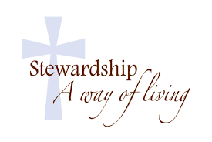

🕆 Sharon Schaible

We utilize the $10,250.04 in interest earned by the DIT accounts (Masters, Endowment, 🕆 Debbie Minton

and Hubbard) to help fund our operational expenses. This is the amount we have budgeted 🕆 Mary Lou Williams

on a regular basis. We didn’t withdraw additional funds from DIT for operations. We also 🕆 Sandy Hickey

received a $4,000 Congregational Grant from the Diocese of Bethlehem 🕆 Jerry Williams

🕆 Jerry Minton

**BUILDING IMPROVEMENTS:**

This past spring our church and halls were painted and cleaned from floor to rafter:

✞ Bonnie Bay, Senior Warden

✞ Jerry Minton, Jr. Warden

✞ Mary Lou Williams, Treasurer

✞ Debbbie Minton, Secretary

✞ Sharon Schaible

✞ Virginia Tuttle

✞ Debbie Virbitsky

✞ Marian McAndrew

✞ Mary Arthur

✞ Angela McHale



* Bonnie Bay, Senior Warden
* Jerry Minton, Junior Warden
* Mary Lou Williams, Treasurer
* Val Agostini, Secretary
* Debbie Minton
* Sharon Schaible
* Virginia Tuttle
* Debbie Virbitsky
* Marian McAndrew
* Mary Arthur
* Beautiful window treatments were made by Ethel and Tom Dougherty for the halls,

kitchen, restrooms and offices.

* A walkway was installed in the churchyard by the Junior Warden,

Jerry Minton and his assistant, Bill Carson.

* The parking area behind the church was cleaned up and leveled with

stone by Rob Tuttle, Jerry Minton, Bill Carson, Ray Arthur, Bonnie Bay

& Jerry Williams.

Special thanks to *Linde Excavating* and *Jermyn Supply* for donating modified stone

to this project. Also, necessary masonry pointing was done on the exterior stonework

of the Church. The designer bingo profits will help defray the cost of masonry work.

**A TRIBUTE TO RICHARD & LILLIAN PENTECOST**  (Written by *Dawn* *Pentecost*)

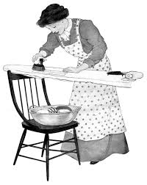It is Friday, January 19, 2018, and the sun is shining, the temperature is warming up, and the weekend is looking spring-like with temps in the 40's & 50’s. I am downstairs ironing, while Tom's Floor is putting a new floor in my bathroom and kitchen. The tiles were the original ones that my father laid when he built the house, but the time had come to pull them up and put down a new floor. As I am ironing I am reflecting on my parents’ and my life. My mother regarded ironing as "resting" and really enjoyed the job. I don't mind ironing either. It is a quiet, reflective time - yes, I guess I would say it is restful.

When you get to my age, I believe that we are all susceptible to reflection: How did your life go? Would you have done anything different? What do you think about your parents and how they brought you up? Before I break into a chorus of "My Way? ("regrets, I've had a few"), I must say that looking back I don't think I would change much. Everything that a person goes through is what makes them who they are. And I have to thank my parents for the strong foundation that they gave me when I grew up.

As I grew older, I was feeling bad that I was not able to eulogize my Mom and Dad when they died. But at that time, that was something that "was not done." I don't think I could have done it anyway - I was so heartbroken when they died that I don't think I could have done it. Even now, I don't think that I would be able to read this aloud. Thus, it is in written form.

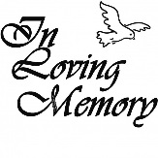

My Dad died in 1973, I was 19 years old, and we were not expecting it. He had a sudden heart attack at work and died at St. Joseph's Hospital before we could get there. I was in shock. He was such a presence in our lives. My Mom died in 2001 when I was 48, at which time she wasn't just my mother, but also my best friend. We had so much in common: We loved to shop, loved antiques, loved to bake and can foods in the summer. We spent a lot of time together. Again, I was heartbroken and devastated, and I probably couldn't have gotten up in front of people at the funeral to speak. So I feel that they were cheated out of the tribute that they deserved. They were both such wonderful people. I was privileged to be their child and I hope that as they look down from Heaven, that they know how much I love and appreciate them.

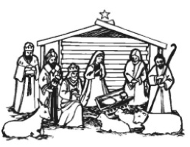One of the interests Mom & I had shared was ceramics which we both attended classes with Helen Burnakis as the teacher. She was from Vandling and attended Christ Church. We had a wonderful time there. But one evening we spied a nativity set that was just the right size, very similar to the size that Mom had bought in the 1940's from Newberry's store. They were painted chalk figures that had a cardboard stable. I was fascinated as a child with that nativity & I would move the figures around like I was reliving the nativity story. What a wonderful story. It grabs the imagination with shepherds and angels, kings coming from afar bearing gifts to a baby who was actually God incarnate who had born in a stable with cows, and horses, etc. So Mom & I decided that we would update our nativity set and paint this new one. So we both worked on the figures and took them home and used them in the cardboard stable. It was soon after that when I started my freshman year at Mansfield. I didn't get much time to get home. But when I came home for Christmas, my Dad said, "I have a surprise for you." And he showed me this brand new stable that he had built (he was a carpenter). For me it was breathtaking! He had built this as a surprise for me. The stable was so authentic. It had hay lofts with a ladder to get up to them, cow stalls, a bench, hay fodders for the animals, and a coiled up piece of twine hanging on a notch that looked like a piece of rope that would be in a stable. The new nativity figures fit in there perfectly. To this day, this is one of my most prized possessions. It is the first thing put up at Christmas, and the last to come down. And I stare at it reliving in my mind that wonderful Christmas story and how wonderful it was for my Dad to build it for me.

Both of my parents came from large families with lots of brothers & sisters which ended in my having lots of aunts, uncles & cousins which was wonderful. There was not a "stinker" among them. I look back at the times spent with the families & they are all good memories. The only sibling of my father's that died before I was born was his brother Paul but somehow I feel a "kindred spirit" with him & I know that I would have loved him as well. He is one of the uncles, that without failure, I put flowers on his grave every year. I could not neglect going to visit Paul.

(Continued)

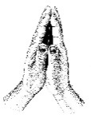My father & my mother were devout Christians. We always went to church & Sunday School. My dad taught the adult class. He was also a lay minister in the Methodist Church and if needed, he would fill in for the minister & give the sermon (which he wrote himself). My mother was his greatest supporter. They were perfect together. So way before *EHARMONY*, they had found each other and made the perfect match. My mother always said that she would be getting into heaven on my Dad's coattails but she really underestimated herself. She lived an exemplary life & gave me a model to follow. Her Bible was always handy & she prayed on everything, not noticeably, but in private. My father's mother was also very devout. My mother told me that when she was pregnant with me and having such a difficult birth, that the doctors were afraid that they might lose either her or me, Dad's mom, Ida Pentecost, was praying constantly. The only way that I can put this, is that she went through her own Lent - tithing, praying constantly, giving up things to guarantee that my mother would get through her pregnancy.

My father worked so hard to support us & send me to school. My mom made all our own clothes, sometimes even coats! And they all looked store-bought. I loved the clothes that she made - I was so proud of her! I never knew that we were in the "poverty range", I always had everything that I ever needed.

My parents both had a wonderful sense of humor - my dad's was on the "dry" side, and my mother's was a little more obvious. She had a contagious laugh & could change a mood from gloomy to joyous in a minute. Mom loved to come into my bedroom in the morning and play *Reveille* on the kazoo to get me up. She loved to tell stories about things that happened to her family when she was growing up. About her mother feeding "bums" during the 20's and 30's, when their family didn't have much either. About silly things that happened to her sisters & brothers, who, by the way, all had great senses of humor.

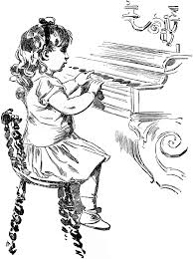I was lucky enough to know both sets of grandparents, including my grandfather, Archie Pentecost, who remarried Mabel Pomeroy (from Canaan Corners area) when he was 80! She was a lovely person and I visited her often. My mother's parents lived two doors away from us and my father's parents lived around the corner. So I was blessed to be able to spend as much time as I did with them. Ma and Pa Jones had a piano in their house which I loved to "play". I was only three or four when I would sit at the piano & "make up songs". Ma Jones was sick in bed at the time, suffering from cancer, but she would ask me to "play her a song". And Grandpa Jones would request “The Missouri Waltz." So when I was five, we got our own piano at our house & Mom set up piano lessons with Mrs. Richards from Jermyn. Mrs. Richards told my mother that she didn't give piano lessons to children that had not entered school yet & could not read. But my mother told her that she would sit with me on the piano bench and read anything I needed to read from the piano books - and she did! She sat with me every day at the piano as I practiced and helped me learn how to play. I owe my love of music and my ability to have lessons at the age of five to my mother's insistence that she would help me learn the piano before I could even read. Later in my lessons, when I was a teenager, I would get to play in Sunday School and sometimes in church, so I was learning solos that could be played in church on the piano. My father's favorite piano solo that I played was "Onward Christian Soldiers" & he would request that I play it for him. When I was about ten, they bought me an organ and arranged to have organ lessons for me. They were both supporters of my venture into music for which I am eternally grateful.

Both of my parents were involved in church & civic work. I know that is where I get the desire to work in the church. But I didn't venture much in to civic work. That was my dad's forte. I am so proud of both of my parents for the lives that they led. They have set a shining example for me to follow for which I am grateful. They were both loving and giving people who shared their lives and love of God with everyone they met. Not overtly, but by their example. As the saying goes, "You might be the only Gospel that some people get to read."

And although I am an only child, I don't feel like an only child. I shared my childhood with my cousins, David & Andy Seaman, whom I saw almost every day. I love them both as if they were my brothers & my mom and dad loved them as though they were their children. It was a great life for all of us.

And so, this is only the tip of the iceberg of the reasons why these two people deserve a tribute. But I had to put this into words because I thought this needed to be said. Someday, we will all be reunited in Heaven, and what a great rejoicing it will be! I love you, Mom and Dad! Thank you! ♥

* 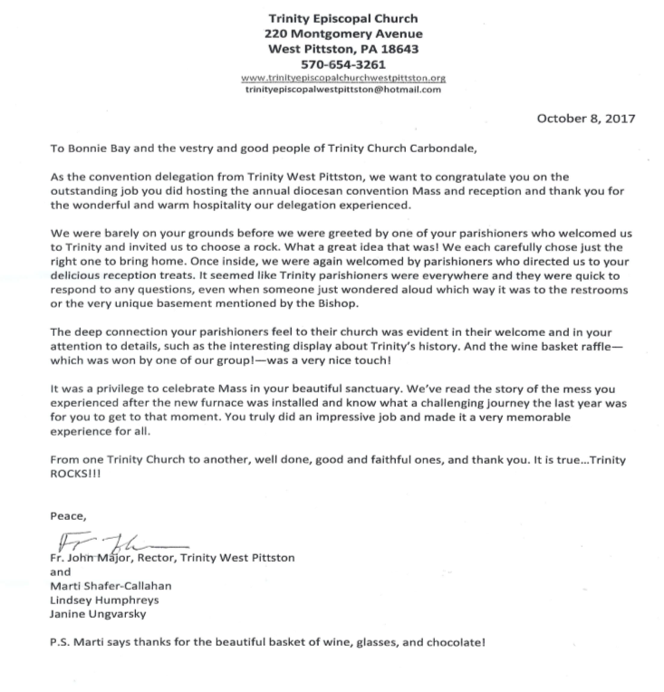Monthly Free Community Social Lunches
* ECW Roast Pork Dinner – February 1st
* Ashes Distributed – February 11th
* Community Lenten Service/Meal – March 14th
* ECW Chicken & Biscuits – March 15th
* Children’s Easter Party – March 25th
* ECW Ham & Scalloped Potatoes – April 26th
* Designer Purse Bingo – May 5th

*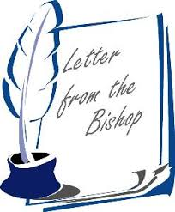“Dear Friends, Please forgive the tardiness of this heart felt Thank You for the beautiful clock you gave me to remember the convention. I will always look back fondly on that event where you showed our diocese your kindness and your manifold gifts of hospitality. The clock and the lovely drawing by Fr. McGinty are monumentally displayed in my office. Blessings to you, 🕆 Sean”*

**146th DIOCESAN CONVENTION – SEPTEMBER 29TH & 30TH**

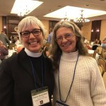

The 146th Episcopal Diocesan Convention was held at the Carbondale Grand Hotel and the reception and mass were hosted by Trinity Church with assistance from Christ Church, Grace Church, and St. James -St. George Church.  Bishop Sean, clergy, delegates from 65 churches and guests had many complimentary remarks; not only about the appearance of our church and grounds, but also the warmth, love and spirituality felt at Trinity. It was truly a joyful reception and glorifying Mass celebration!

Canon Rev. Ann Kitch &

Bonnie Bay, Sr. Warden

*“Trinity Church strives to be a beacon of light in the community and to welcome all people to join us in celebrating God, by doing good works for his people”*

|  |  |  |
| --- | --- | --- |
| Trinity Episcopal Church 58 River Street  Carbondale PA 18407  Phone: (570) 282-3620  Email:[trinitychurch@echoes.net](mailto:trinitychurch@echoes.net)  Trinity’s Website: [www.trinity-episcopal.weebly.com](http://www.trinity-episcopal.weebly.com) |  | [Street Address]  [City, ST ZIP Code] |