TRINITY TODAY NEWSLETTER
Email: Trinityepiscopal@echoes.net Website: http://trinity-episcopal.weebly.com

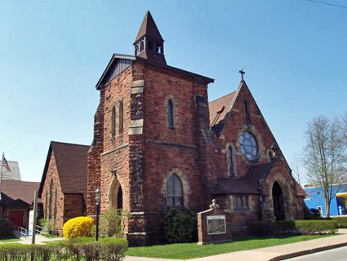

- Cherry Peck Benefit Dinner & Raffle – April 1st
- Tai Chi Classes – Monday Evenings
- Maundy Thursday @ Christ Church, Forest City
Kids Easter Party/Egg Hunt
- Good Friday Service @ Trinity
- Monthly Free Community Social Lunches
- ECW Flea Market – September & February
- Share the Harvest Food Give-Away
- Dicken's Christmas Dinner - Dec. 17th
- Chicken & Biscuits Dinner - Oct 27th
- ECW Pork Dinner – February
- Trick or Treating Hallo-Weiner Give Away-
- Wickie's Christmas Bazaar - Nov. 12th
- March Calendar Lottery
- Furnace repaired and cleaned
- Kitchen commercial stove cleaned & serviced
- Elinor’s 90th Birthday Party
- Serve Pro cleaned church floor to rafters
- Church painted by Sutor Painters
- Hall Floors refurbished by Serve Pro
- Incinerator chimney torn down by Mark Sheare Construction

- Easter Vigil Service @ St. James/St. George
- Easter Service @ Trinity (11:00)
- Monthly Free Community Social Lunches
- (Watch Adams TV or Visit Our Website for Dates)
- Weekly Knitting/Craft Group-Friday afternoons from 3:00 pm – 4:00 pm.
- ECW’s Flea Market – May 6th
- National Day of Prayer Service–7 pm @ Train
Station

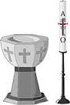 Congratulations & May God Bless our Newly Baptized with all his love & care.
` Jacob Walker Hayes December 18, 2016 Jenna Leanne Saam
January 22, 2017

Rodney Gravine November 6th
Glen Capschull November 7th
November 10th Ryan & Randi Bannon
November 14th Donna & Glen Kapschull
December 3rd Kathy Sue & Gary Loyack
January 8th Bonnie & Glenn Bay
January 17th Sandra & Robert Hickey
January 18th Rev. & Mrs. Maytlycewicz

Ed Bannon November 9th
Keneth Virbitsky November 19th
Becky Murray November 19th
Marge Schoefield November 22nd
Madelyn McHale November 22nd
Lucas Nevins December 7th
Susan Chaballa December 13th
Maria Virbitsky December 19th
Ryan Bannon December 20th
Randi Bannon December 22nd
Donna Capschull December 30th
Peter Barnes January 5th
Gary Loyak January 5th
Mrs. William Pierce January 14th
Cathy Nevins January 14th
Episcopal Church Women:

- Debbie Virbitsky, President
- Bonnie Bay, Vice President
- Val Agostini, Secretary
- Patti Turano, Treasurer

All Episcopal women & friends are considered members of E.C.W.

Hello You Fabulous Members of Trinity Church,
- Bonnie Bay, Senior Warden
- Jerry Minton, Junior Warden
- Mary Lou Williams, Treasurer
- Val Agostini, Secretary
- Debbie Minton
- Sharon Schaible
- Virginia Tuttle
- Debbie Virbitsky
- Marian McAndrew
- Mary Arthur

You and your church are awesome!!!! Your Vestry
has been hit by so many obstacles, but yet you keep
progressing on…..you are a credit to the community
and the Episcopal Church. Looking for a great year.

Ray Poggensee (St. James-St. George, Jermyn, PA)

CHURCH SERVICE & ACTIVITY CANCELLATIONS
We have a special telephone line to inform everyone
if church service or activities will be cancelled
due to bad weather or unseen circumstances.

Call or (570) 680-1900

"Trinity Mission Statement: “Trinity Episcopal Church strives to be a beacon of light in the community and to welcome all people to join us in celebrating God by doing good works for His people.”

Trinity Episcopal Church
58 River Street
Carbondale, PA 18407

